**Test Case** **0015**

**System:** VirtuCardsClient & VirtuCardsHost

**Description:** Make sure players can play valid cards during turn.

**Severity:** 2

**Instructions**

**Test 1**

1. Start VirtuCardClient application
2. Click the button labeled “Sign In”
3. Enter “virtucards01@gmail.com” into the text input labeled “Enter email…”
4. Enter “Testing1” into the text input labeled “Enter password…”
5. Press the button labeled “Login”
6. A window should appear saying “Login Success”
7. Press the OK button that appears on that window
8. Start VirtuCardHost application
9. Repeat steps 2-7 but on the VirtuCardHost application
10. The checkbox “Allow Host to Join” should be checked on the host
11. Click the dropdown and select Testgame mode
12. Press the Create Game button
13. In the VirtuCardClient application enter the 6-character room code found on the host’s screen into the field labeled “Enter Code…”
14. Press the Join Game button on the client
15. The client should be taken to a waiting screen and the username “Testing0001” should appear on the host.
16. Press the Start Game button on the host.
17. Once the client is in game hit the draw card button

**Expected Result:** The client should have a card added to their hand.

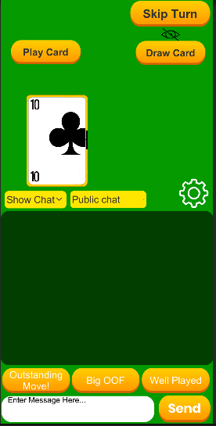

* When the client draws a card this is what there screen should look like. In this scenario the client has drawn a 10 of clubs

1. Now click the play card button while the card that was just drawn is selected

**Expected Result:** The card should be played, going from the client’s hand to the host screen

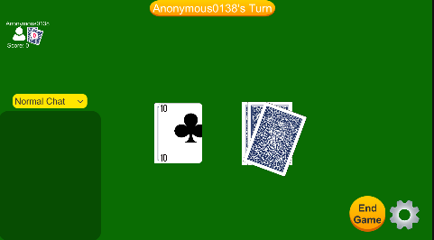

* Once the client has played the card, it will be sent and displayed on the top of the played card pile on the host screen

**Test 2**

1. Start VirtuCardClient application
2. Click the button labeled “Sign In”
3. Enter “virtucards01@gmail.com” into the text input labeled “Enter email…”
4. Enter “Testing1” into the text input labeled “Enter password…”
5. Press the button labeled “Login”
6. A window should appear saying “Login Success”
7. Press the OK button that appears on that window
8. Start VirtuCardHost application
9. Repeat steps 2-7 but on the VirtuCardHost application
10. The checkbox “Allow Host to Join” should be checked on the host
11. Click the dropdown and select Testgame mode
12. Press the Create Game button
13. In the VirtuCardClient application enter the 6-character room code found on the host’s screen into the field labeled “Enter Code…”
14. Press the Join Game button on the client
15. The client should be taken to a waiting screen and the username “Testing0001” should appear on the host.
16. Press the Start Game button on the host.
17. Once the client is in game hit the draw card button three times

**Expected Result:** The client should have three cards added to their hand

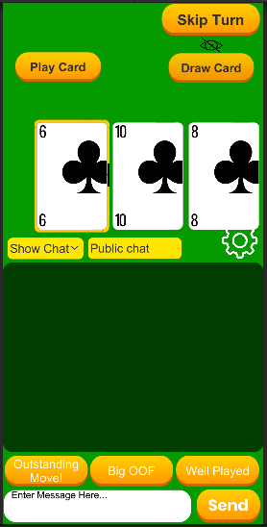

* This is what the client hand will look like after drawing three cards.

1. Now click the play card button on one of the selected cards.

**Expected Result:** The card should be played, going from the client’s hand to the host screen

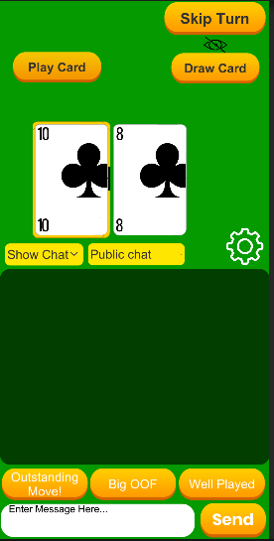

* After the 6 of clubs is played the client should not have it

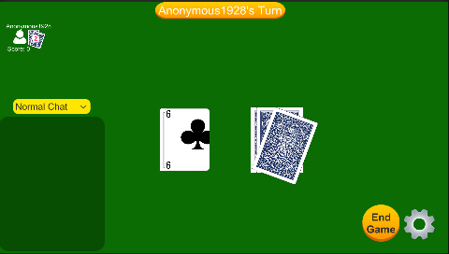

* After the initial 6 is played, this is what the host screen should display

1. Repeat step 18 until the hand is empty

**Expected Result:** All cards should be removed from the client’s hand and sent to the host screen

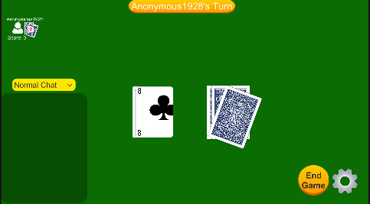

* After all cards have been played this is what the host screen should display

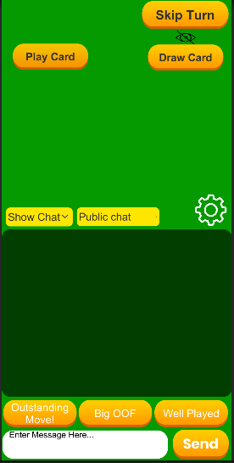

* The client should have a completely empty hand at this point.

**Test 3**

1. Start VirtuCardClient application
2. Click the button labeled “Sign In”
3. Enter “virtucards01@gmail.com” into the text input labeled “Enter email…”
4. Enter “Testing1” into the text input labeled “Enter password…”
5. Press the button labeled “Login”
6. A window should appear saying “Login Success”
7. Press the OK button that appears on that window
8. Start VirtuCardHost application
9. Repeat steps 2-7 but on the VirtuCardHost application
10. The checkbox “Allow Host to Join” should be checked on the host
11. Click the dropdown and select Testgame mode
12. Press the Create Game button
13. In the VirtuCardClient application enter the 6-character room code found on the host’s screen into the field labeled “Enter Code…”
14. Press the Join Game button on the client
15. The client should be taken to a waiting screen and the username “Testing0001” should appear on the host.
16. Press the Start Game button on the host.
17. Once the client is in game hit play card button

**Expected Result:** Nothing should happen, as the player does not have a card yet.

1. Click the draw card button on the client

**Expected Result:** The client should have a card added to their hand.



* When the client draws a card this is what there screen should look like. In this scenario the client has drawn a 10 of clubs

1. Click the play card button

**Expected Result:** The card should be played, going from the client’s hand to the host screen



* Once the client has played the card, it will be sent and displayed on the top of the played card pile on the host screen

**Test 4**

1. Start VirtuCardClient application
2. Click the button labeled “Sign In”
3. Enter “virtucards01@gmail.com” into the text input labeled “Enter email…”
4. Enter “Testing1” into the text input labeled “Enter password…”
5. Press the button labeled “Login”
6. A window should appear saying “Login Success”
7. Press the OK button that appears on that window
8. Start VirtuCardHost application
9. Repeat steps 2-7 but on the VirtuCardHost application
10. The checkbox “Allow Host to Join” should be checked on the host
11. Click the dropdown and select Testgame mode
12. Press the Create Game button
13. In the VirtuCardClient application enter the 6-character room code found on the host’s screen into the field labeled “Enter Code…”
14. Press the Join Game button on the client
15. The client should be taken to a waiting screen and the username “Testing0001” should appear on the host.
16. Press the Start Game button on the host.
17. Once the client is in game hit the skip turn button

**Expected Result:** The turn should be rotated around back to the players

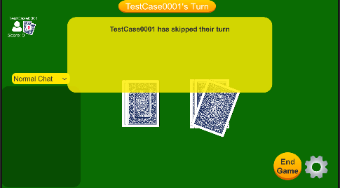

* The host will briefly display this showing that the player has skipped their turn

1. Now click the add card button for that player
2. Click play card with that card selected

**Expected Result:** The card should be played, going from the client’s hand to the host screen

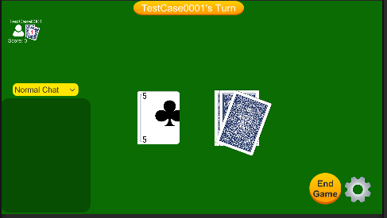

* After drawing a card and playing it, the host should still update even though the player has attempted to manipulate the order of players playing with one person in the lobby